***ES6 ( ECMAScript ) Documentation***

* It is used by applications to enable client-side scripting language.
* JavaScript can run on any browser, any host, and any OS.

### **Installing Node.js**

* Node.js is an open source, cross-platform runtime environment for server-side JavaScript.
* Node.js is required to run JavaScript without a browser support.
* It uses Google V8 JavaScript engine to execute the code.
* You may download Node.js source code or a pre-built installer for your platform.
* Node is available at [https://nodejs.org/en/download](https://nodejs.org/en/download/)

## **Installation on Windows**

* Download and run the .msi installer for Node
* To verify if the installation was successful, enter the command node –v in the terminal window.
* A JavaScript program can be composed of −

**Variables** − Represents a named memory block that can store values for the program.

**Literals** − Represents constant/fixed values.

**Operators** − Symbols that define how the operands will be processed.

**Keywords** − Words that have a special meaning in the context of a language.

### **Installing ES6 setup with babel:**

**Please see ref video:**

* https://www.youtube.com/watch?v=VrlDhlPbVkk

**Example:**

1. **Let:**

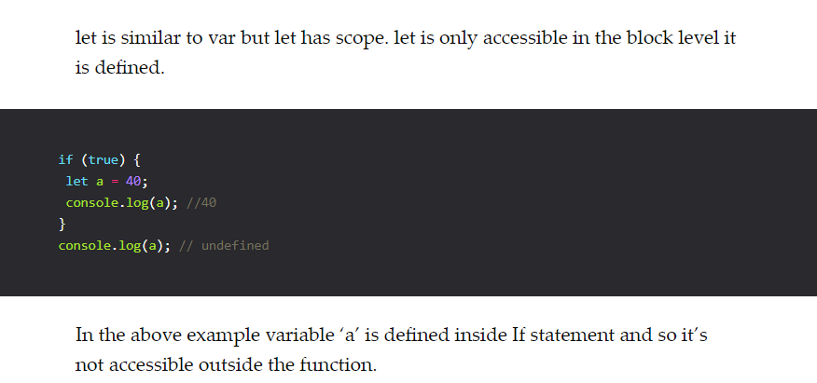

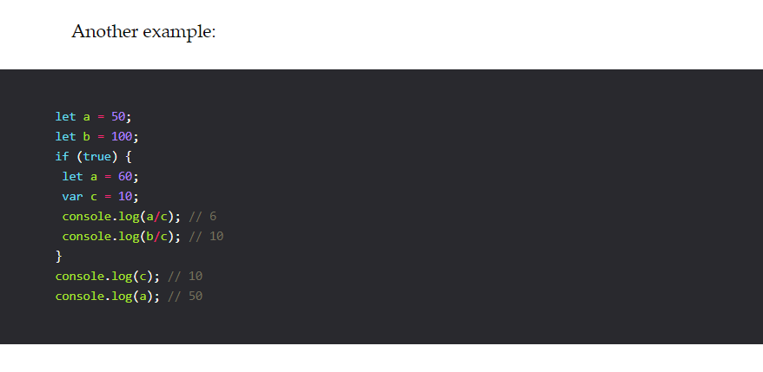

**2. Const**

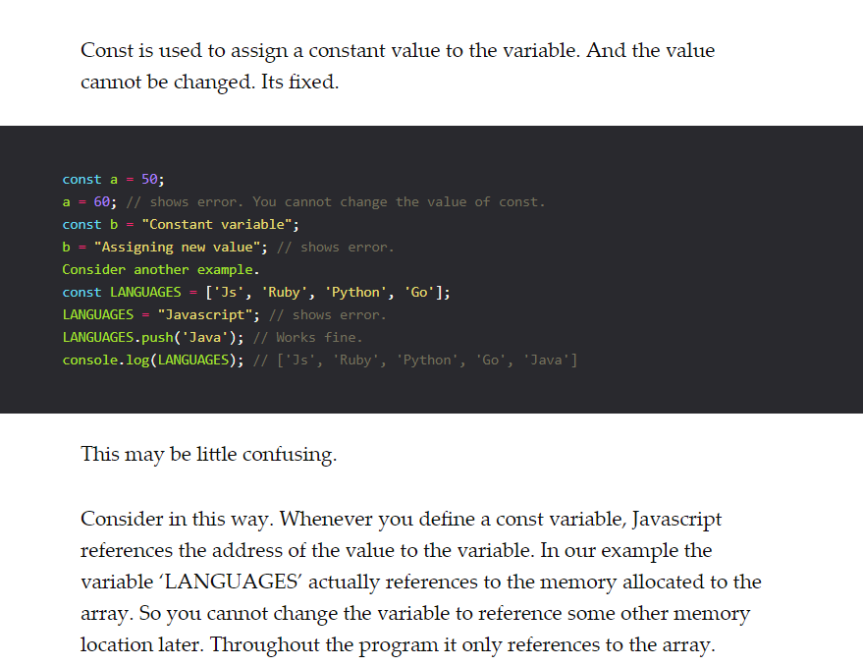

**3. Arrow Function**

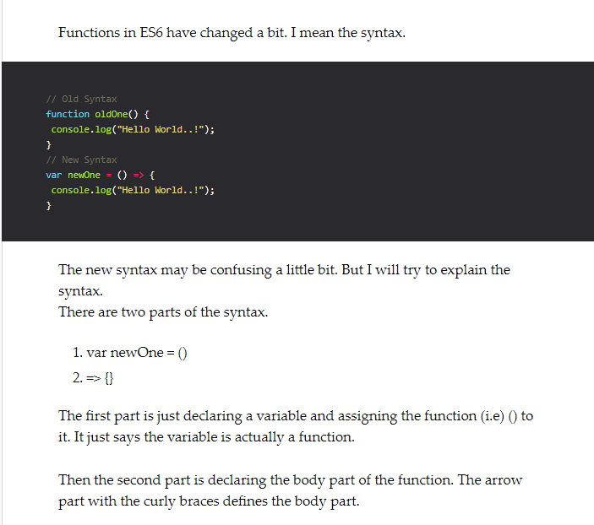

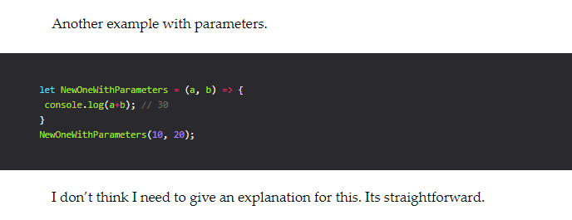

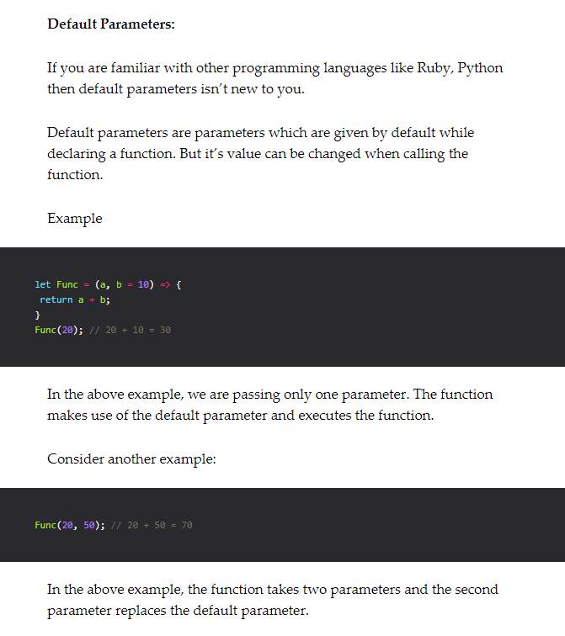

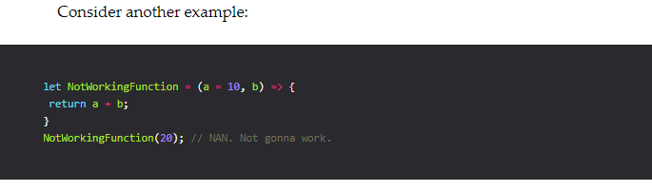

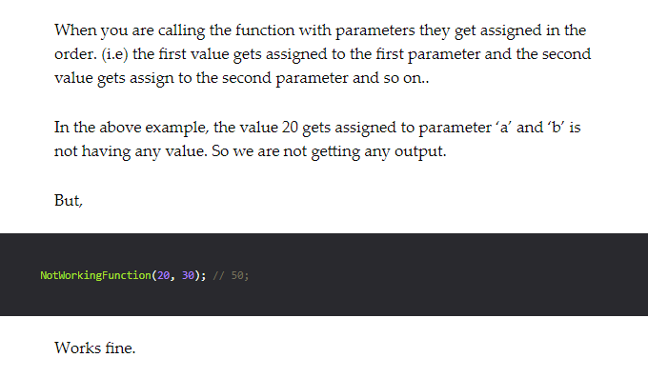

**For of loop**

for..of is very similar to for..in with slight modification.

for..of iterates through list of elements (i.e) like Array and returns the elements (not their index) one by one.

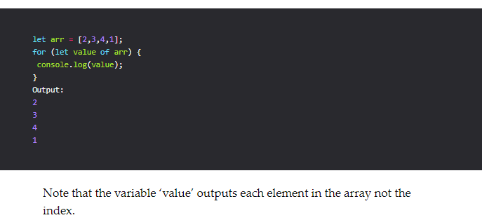

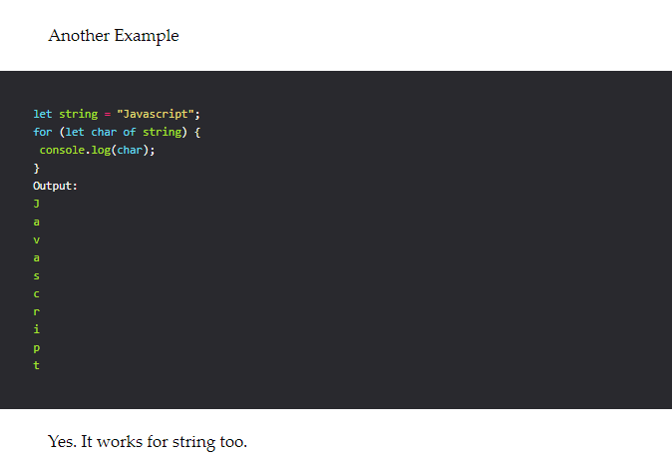

**Spread attributes**

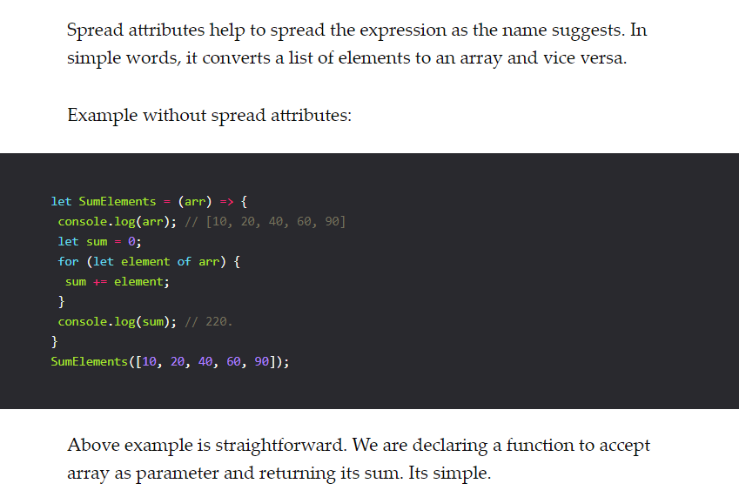

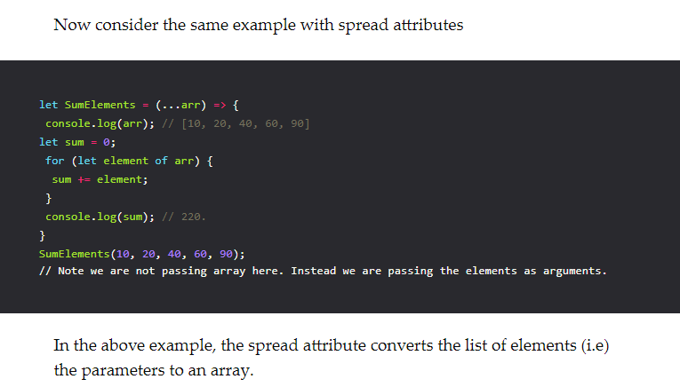

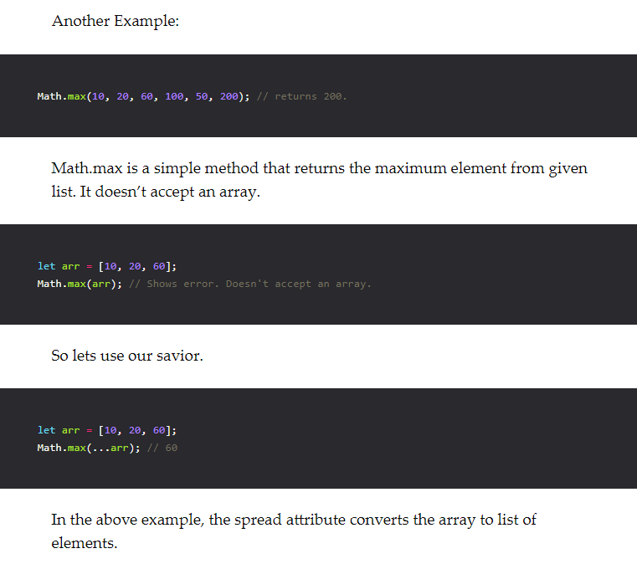

**Maps**Map holds key-value pairs. It’s similar to an array but we can define our own index. And indexes are unique in maps.

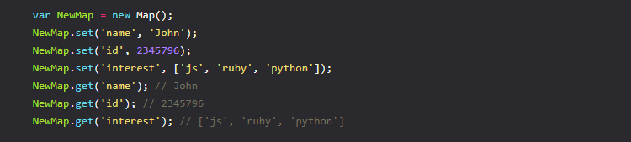

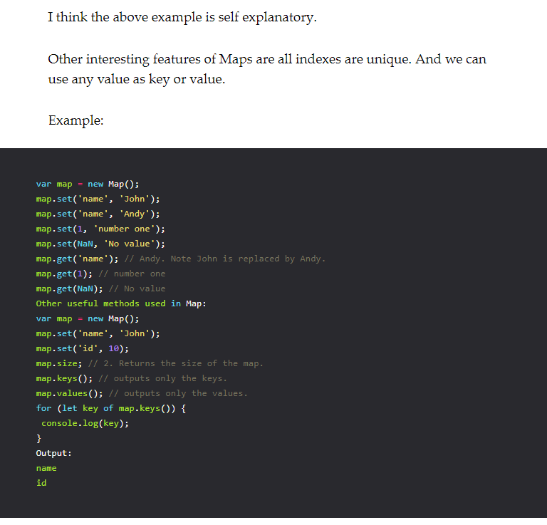

In the above example, map.keys() returns the keys of the map but it returns it in Iterator object. It means that it can’t be displayed as it is. It should be displayed only by iterating.

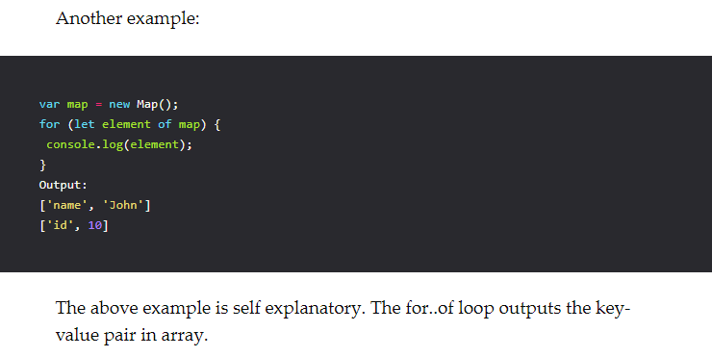

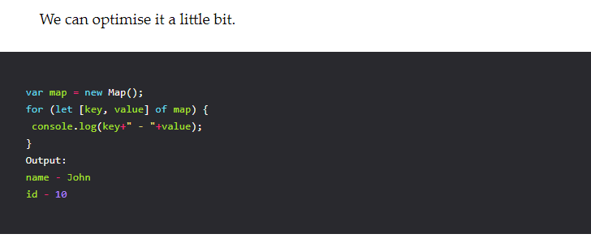

**Sets**

Sets are used to store the unique values of any type. Simple..!

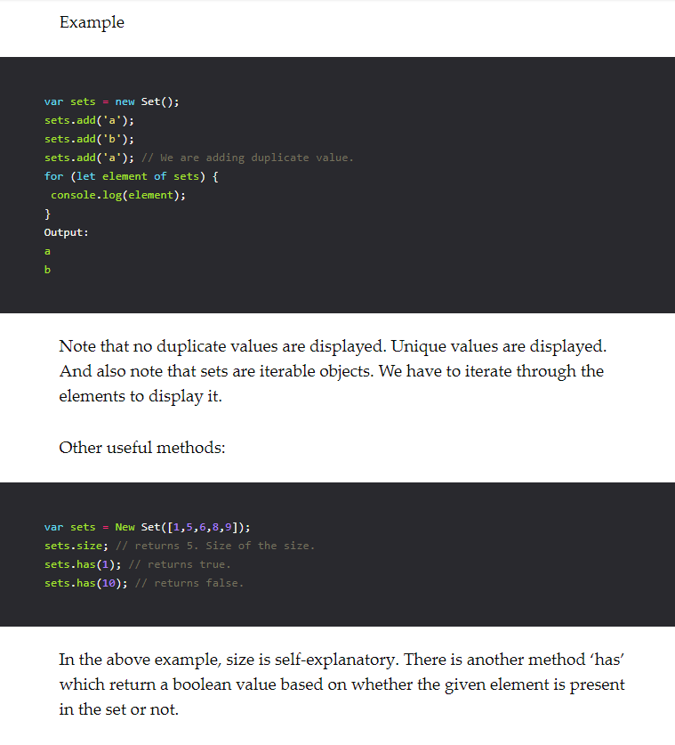

**Static methods**

Most of you have already heard about static methods. Static methods are introduced in ES6. And it is pretty much easy to define it and use it.

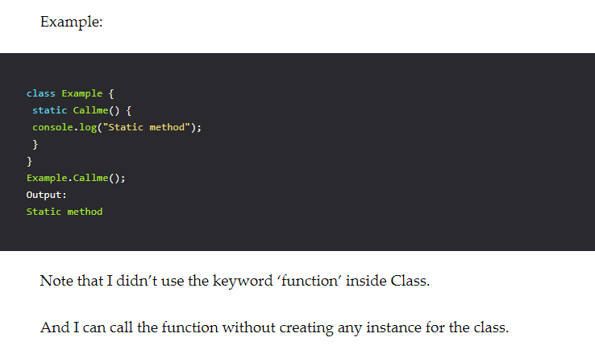

**Getters and Setters**

Getters and setters and one of the useful feature introduced in ES6. It will come in handy if you are using classes in JS.

I think the below first one example is self-explanatory. We have two functions in class People that helps to set and get the name of the person.

Example without getters and setters:

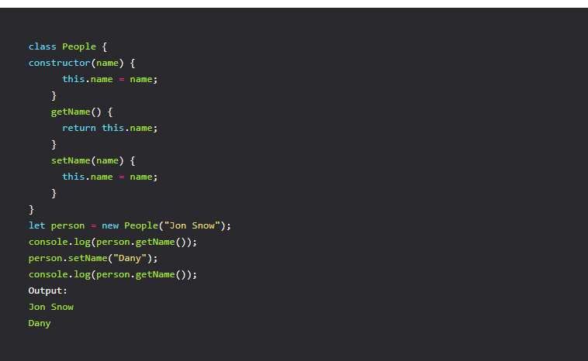

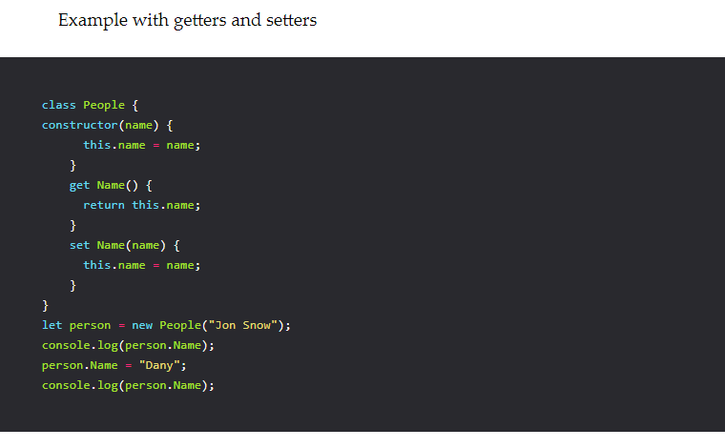

In the above example, you can see there are two functions inside class People with ‘get’ and ‘set’ properties. The ‘get’ property is used to get the value of the variable and ‘set’ property is used to set the value to the variable.

And you can see that getName function is called without parenthesis. And setName function is called without parenthesis and it’s just like assigning a value to the variable.

https://appdividend.com/2017/03/28/beginners-guide-to-setup-es6-development-environment/#Step_2_Create_a_packagejson_file